We will now look at how we can format our selection screens. And this will help us make our selection screens look a lot more attractive and intuitive to the user.



the first thing we're going to look at is blank lines. So, if we want to insert a blank line between parameters and things like that, we will use, the SKIP addition.



And what we do is specify the number of lines we want to skip, and that's represented here, in these square brackets.

Now, the simplest form is to leave the number of lines out, and just by using SKIP, that will mean we just want to skip one line.

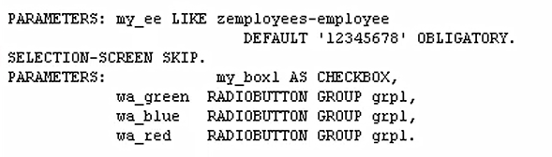

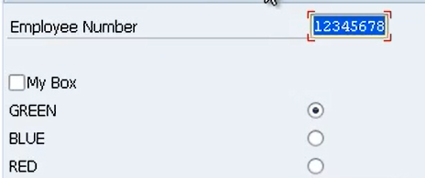

So, you can see here, we have the employee number parameter, then we have a blank line where we skipped one line. And then we get the check box and radio buttons.

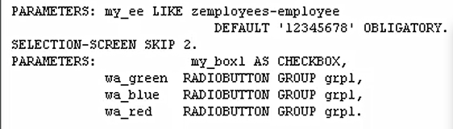

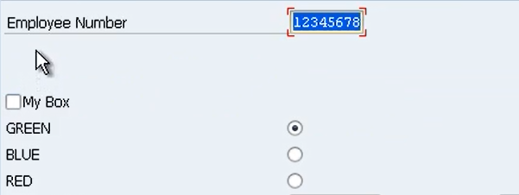

Now, if we wanted to skip two lines, we have the number 2. And as you can see in the test, we now have two lines.

Now we add a vertical line to the screen.

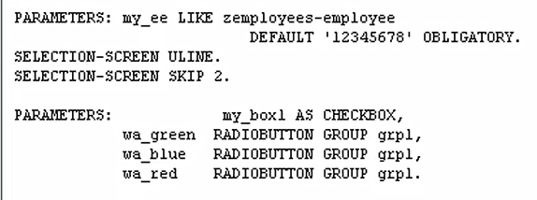

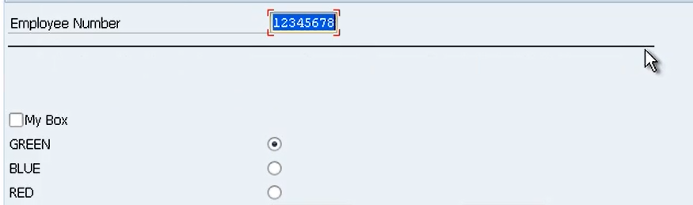

ULINE means underline.

There are some additions we can add to the underline. We have a position and a length addition.

